



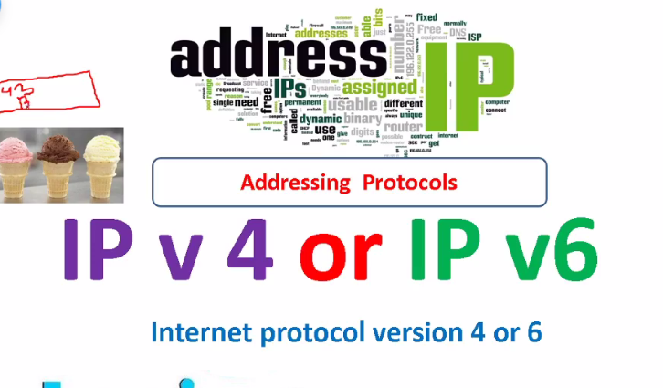

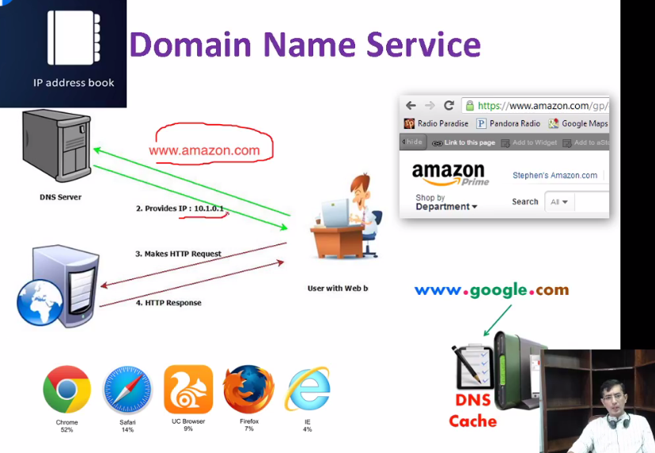

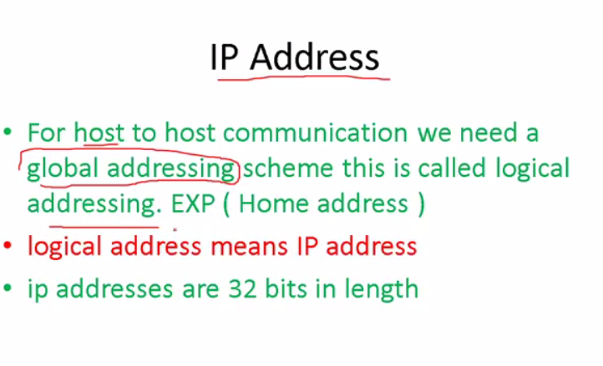

Khud manually assign krtey h 32 bit in length 32/4

Machine ip address k through identify krti h

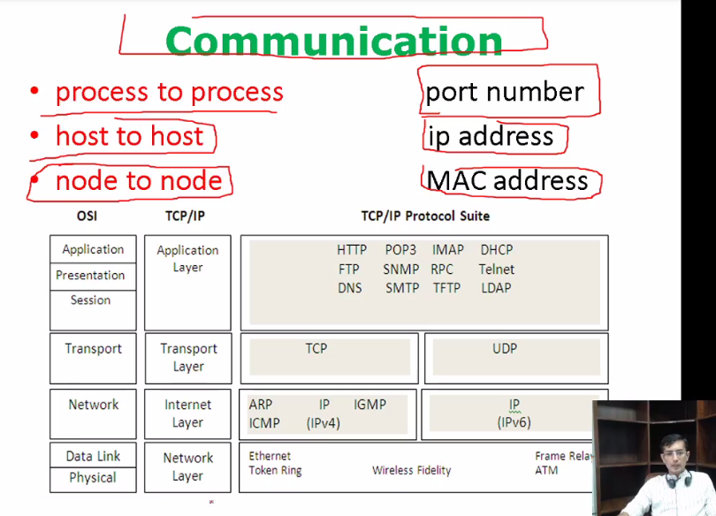

Node to node 🡪mac

Process to process->port no

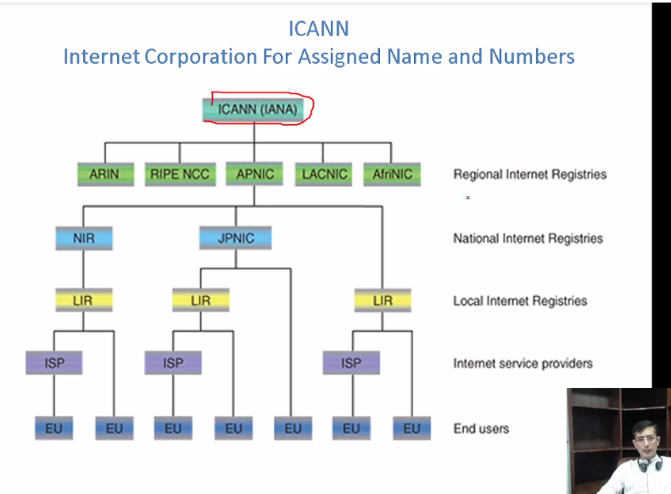

Regions h jse asia Africa (country wale national devices par deti h jse ptcl wagera phir ptcl se jaaz song ya

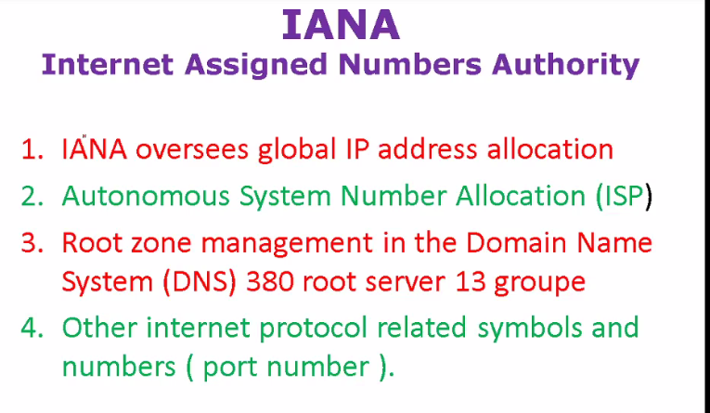

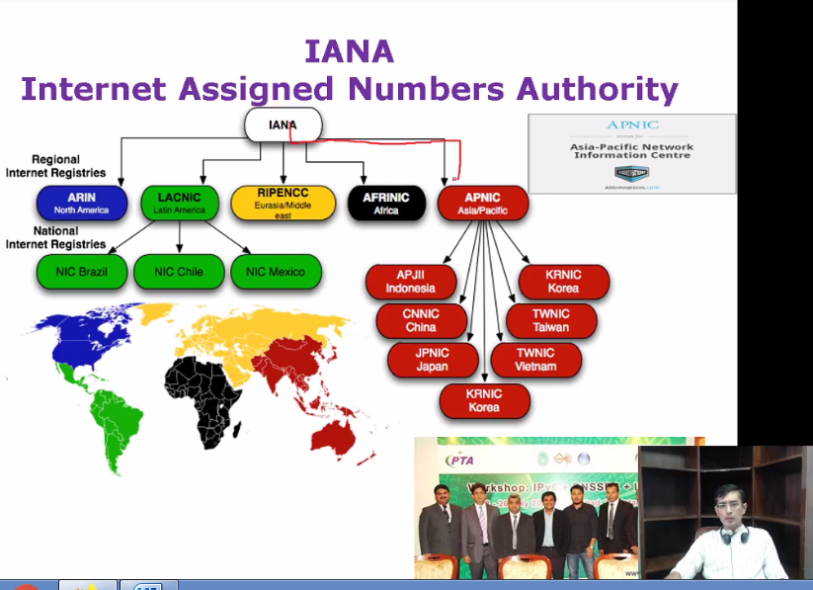

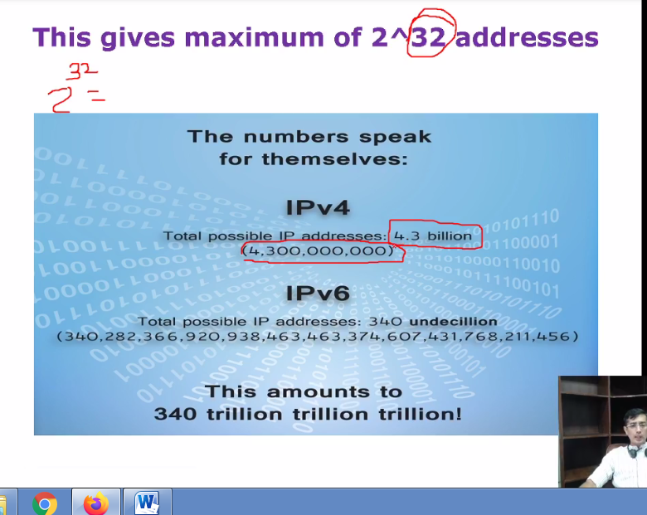

Ip4 last decade m hi short hogaya tha

Ipv6 ab use hota h 128 bit ka ..

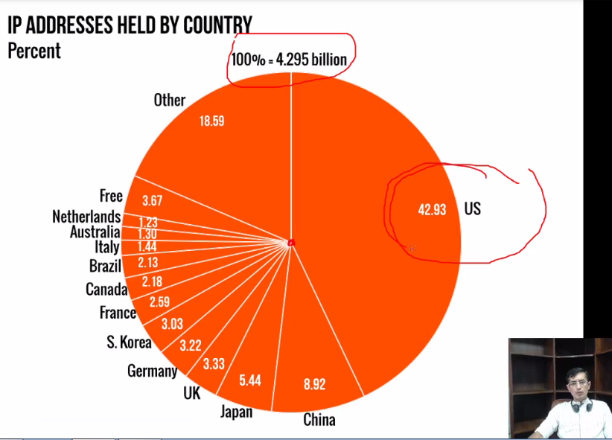

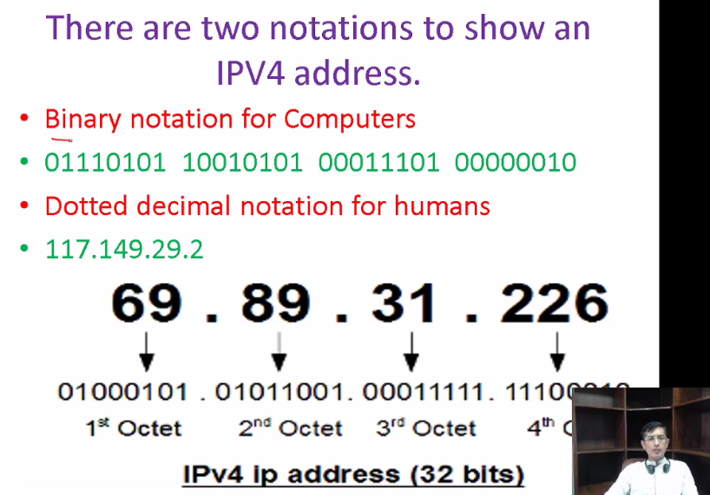

Binary for comp

4 octet h is m separated by (“ . ”)

Ek octet =8bit ya toh 0 ya max 1



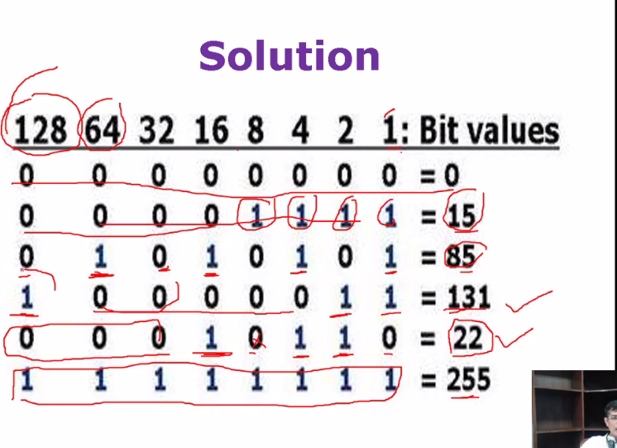

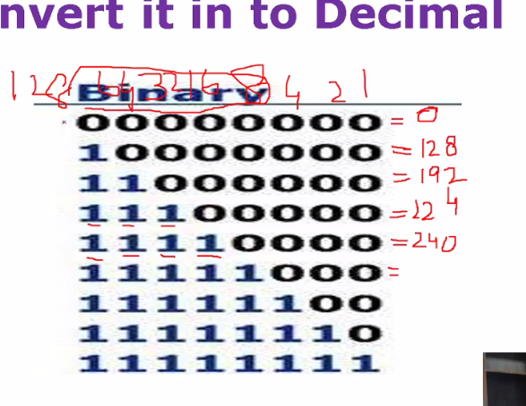

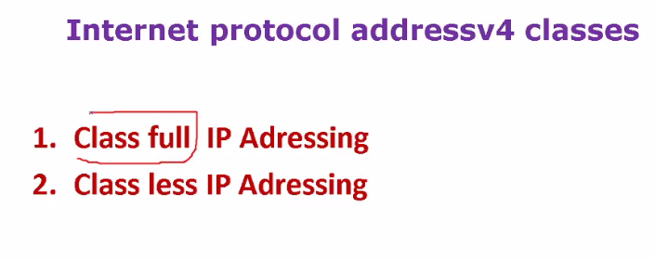

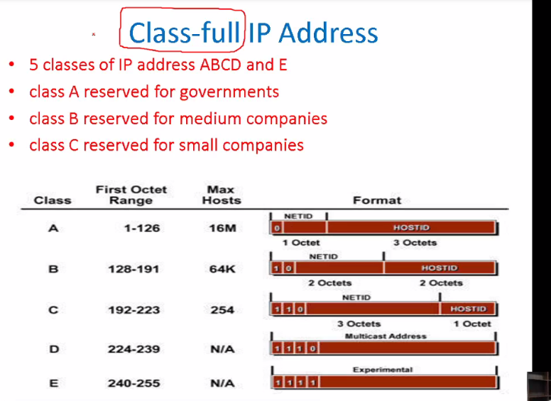

Classfull -🡪5 classes

In class A:1st octet is n/w 🡪

In class B :2 octet are for n/w

In class C :4 octet are for n/w

In class C :4 octet are for n/w

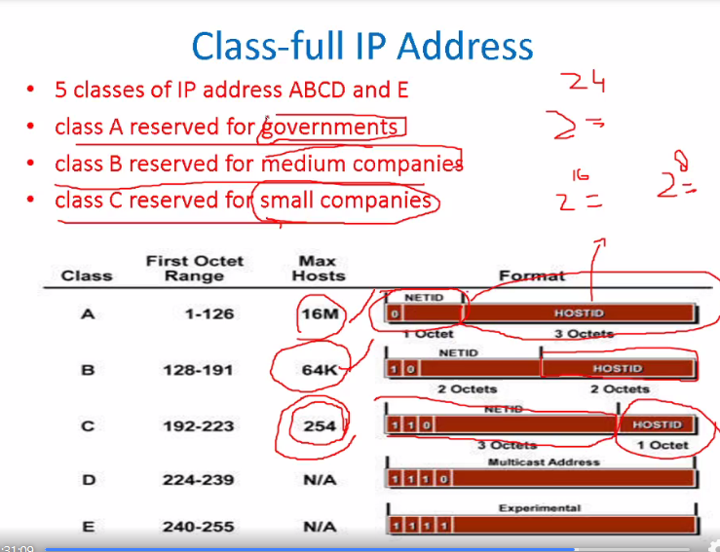

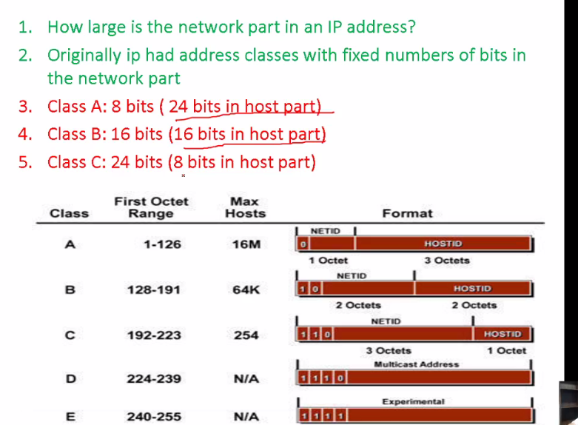

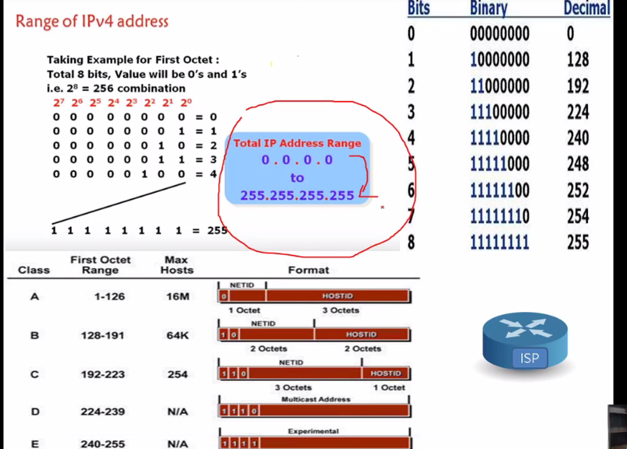

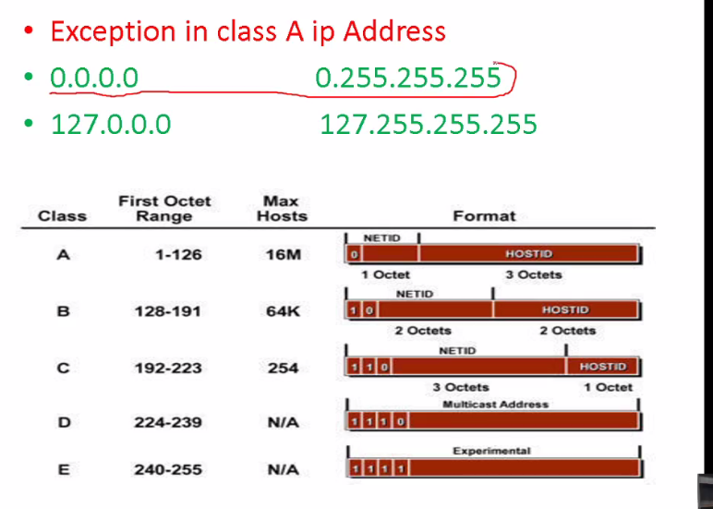

127.0.0.1-127.255.255.255 ->Testing k lye n/w nh h phir bhi run krne h toh mltb apne ap ko hi ping krnaa

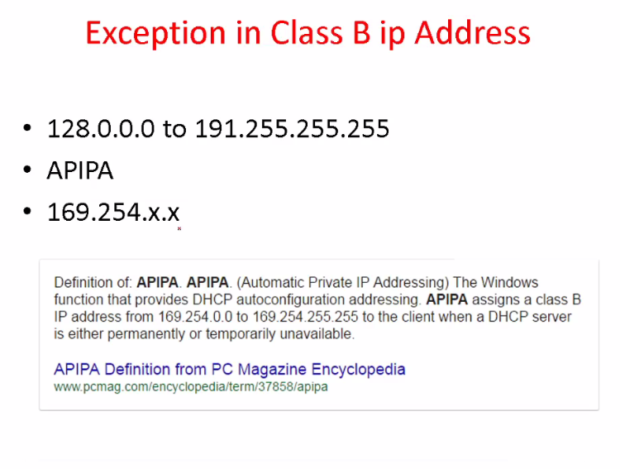

Apipia ki ip hoti h

Dhcp se agar koi ip na mile ya dhcp server avaible na ho toh wo thori dair bd khud ko yeh assign krleta h

169.254.x.x comm krskta h but gateway ko corss nh krksta is ip k sth

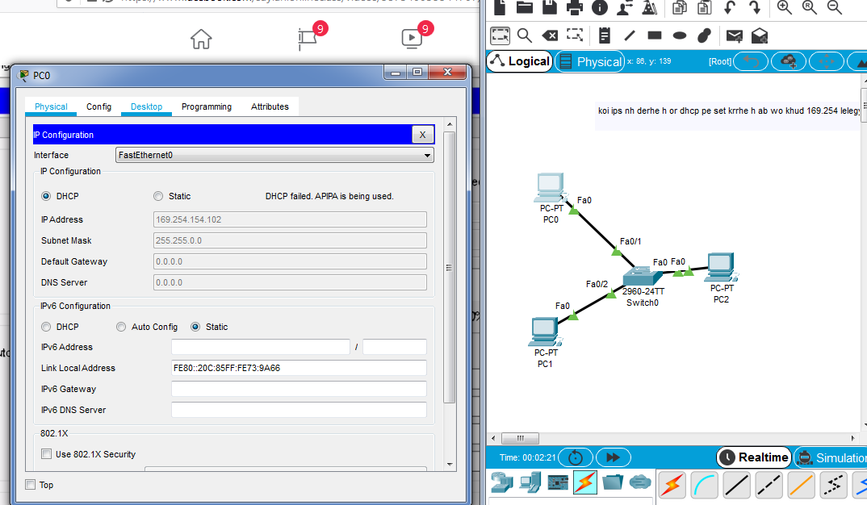

Local n/w m ping bhi horhaa h

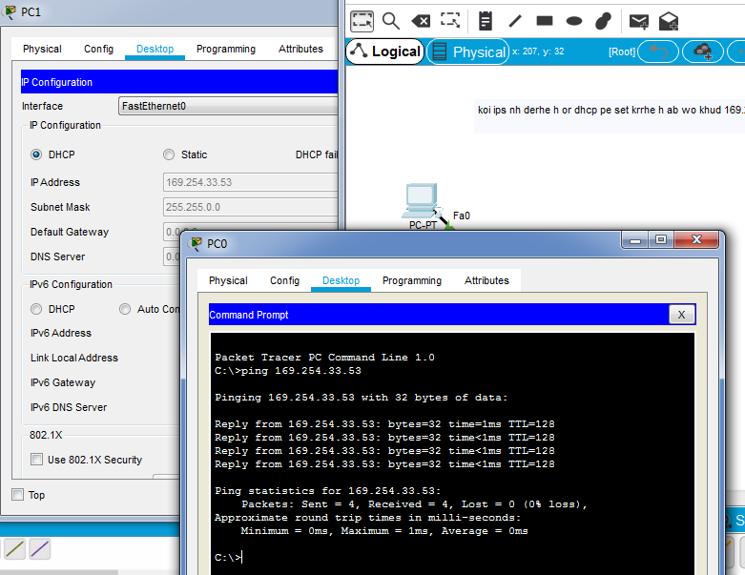

Class C

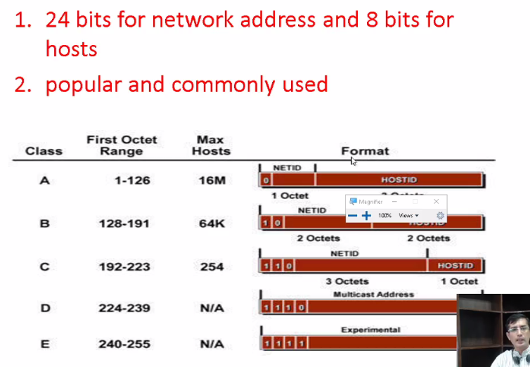

192-223 range value

Yahan host km h but n/w bht ziyada h means 2^24 bht ziyada h islye mostly use hota h

Class D

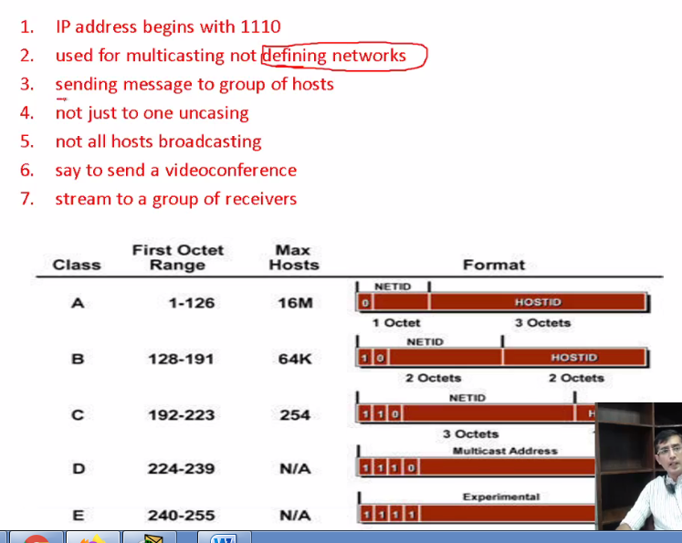

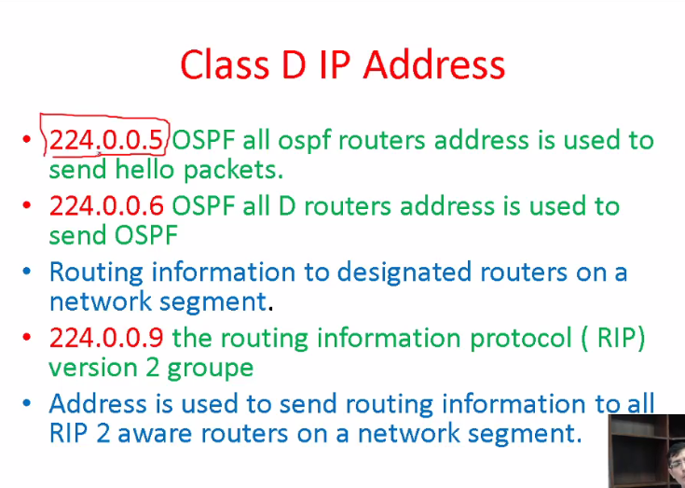

Routers wagera use krtey h yeh

Ospf m hello wagera k lye designated k lye rip 224.0.0.9 pe bhjrha hota h

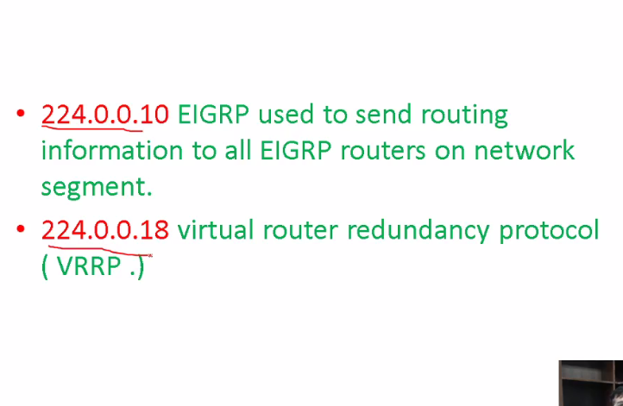

Class E:

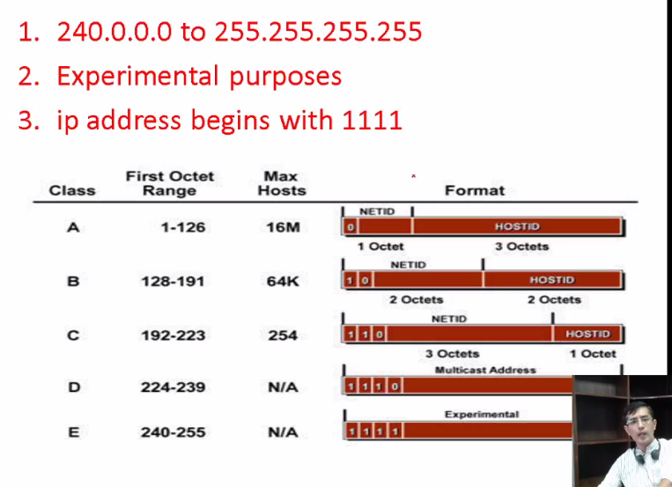

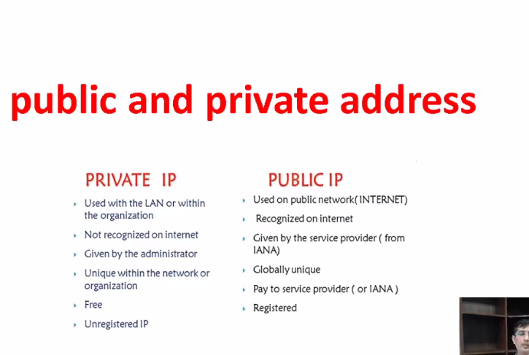

Ips ko perverse safe krne k lye we use private ips agar ips ki range 1-100 h toh ainaa ne 1-15 tk ki ips ko rivate krdia baki 16-100 ips public h

Internet k upper ana h toh you should use public ip . aar apo apne company m koi n/w banana ho toh private use krle ..without payement you can use in your n/w A B C X Y Z sab use krle ..lkn agar use connect krna h toh net k sth tooh should buy public ips

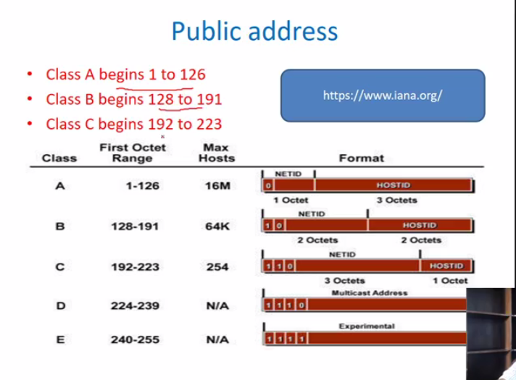

Har class se e kip ko le kr rivae k lye assign krde h baki sare public h

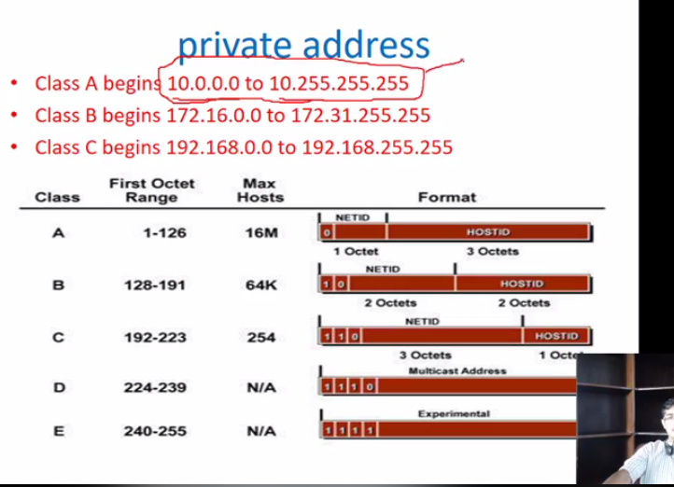

10.0.0. 0--10.255.255.255

172.16.0.0--172.16.255.255

192.168.0.0 --192.168.255.255

Network Mask:

Ktna n/w portion h or ktna host portion

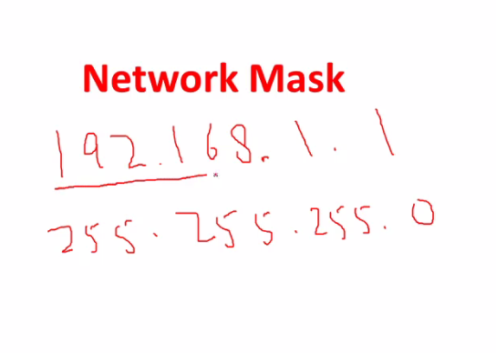

Host ki jaagah 0 lkhna h

